REPUBLIC OF GHANA

COMPOSITE BUDGET

FOR 2021-2024

PROGRAMME BASED BUDGET ESTIMATES

FOR 2021

KUMASI METROPOLITAN ASSEMBLY

Table of Contents
PART A: STRATEGIC OVERVIEW 3
1. ESTABLISHMENT OF THE METROPOLITAN ASSEMBLY 3
2. VISION OF KUMASI METROPOLITAN ASSEMBLY 3
3. MISSION STATEMENT 3
4. GOAL 3
5. CORE FUNCTIONS 3
6. METRO ECONOMY 4
7. KEY ACHIEVEMENTS IN 2020 9
8. FINANCIAL PERFORMANCE FOR 2020 13
9. ADOPTED POLICY OBJECTIVES IN LINE WITH SDGs, TARGETS AND COST 17
10. POLICY OUTCOME INDICATORS AND TARGETS 18
11. REVENUE MOBILIZATION STRATEGIES FOR MAJOR REVENUE SOURCES 20
PART B: PROGRAMME 1: MANAGEMENT AND ADMINISTRATION 21
SUB PROGRAMME SP1.1: GENERAL ADMINISTRATION 23
SUB PROGRAMME SP1.2: Planning and Coordination 26
SUB PROGRAMME SP1.3: Legal 29
SUB-PROGRAMME 1.4 Human Resource Management 31
PROGRAMME 2: INFRASTRUCTURE DELIVERY AND MANAGEMENT 33
SUB PROGRAMME SP2.1: Public Works Service 35
SUB PROGRAMME SP2.2: Urban Roads Management 38
SUB PROGRAMME SP2.3: Physical and Spatial Planning Development 41
PROGRAMME 3: SOCIAL SERVICES DELIVERY 43
SUB PROGRAMME SP3.1: Education, Youth and Sports Management 45
SUB PROGRAMME SP3.2: Social Welfare and Community Development 47
SUB PROGRAMME SP3.3: HEALTH SERVICES DELIVERY 49
PROGRAMME 4: ECONOMIC DEVELOPMENT 51
SUB PROGRAMME SP4.1: Development of Trade and Industry 52
SUB PROGRAMME SP4.2: Transport and Traffic Management 54
SUB PROGRAMME SP4.3: Agricultural Development 56
SUB PROGRAMME SP4.4: TOURISM DEVELOPMENT 58
PROGRAMME 5: ENVIRONMENTAL AND SANITATION MANAGEMENT 60
SUB PROGRAMME SP5.1: DISASTER DEVELOPMENT AND MANAGEMENT 62
SUB PROGRAMME SP5.2: ENVIRONMENTAL PROTECTION AND WASTE MANAGEMENT 64
SUB PROGRAMME SP5.3: RESOURCE CONSERVATION 67
PROGRAMME: BUDGET AND FINANCE 69
SUB PROGRAMME SP6.1: Finance and Audit Operations 70
SUB PROGRAMME SP6.2: Budgeting and Rating 72
PART C: CASH PLAN FOR THE 2020 FISCAL YEAR 75

PART A: STRATEGIC OVERVIEW

1. ESTABLISHMENT OF THE METROPOLITAN ASSEMBLY
Kumasi Metropolitan Assembly is one of the forty three (43) districts in Ashanti Region. It was established by Legislative Instrument 2260 of 2018. It is 275.8 km from Accra.
1.1 LOCATION AND SIZE
Kumasi covers a total land area of approximately 78.28km² and shares boundaries with Afigya Kwabre, Suame and Tafo to the north, Asokore Mampong and Oforikrom to the east, Asokwa to the south – east, Atwima Kwanwoma to the south and Kwadaso to the west.
1.2 POPULATION
Kumasi had a population of 1,730,249 according to the 2010 Population and Housing Census. However, due to the creation of five (5) Municipalities out of Kumasi Metropolitan Assembly, the city’s population is currently estimated to be 728,634. With an intercensal growth rate of 3.910%, it is estimated to increase to 731,487 in 2020 and 731,774. It has a sex ratio of 91.4.
The population density of the city is 9,348 persons per square kilometer. It is completely urbanized therefore all the population reside in urban localities. However, 500,000 residents from the surrounding Districts work in KMA during daytime.

2. VISION OF KUMASI METROPOLITAN ASSEMBLY
To become a Safe, smart City and Investment destination for both local and international investor’s

3. MISSION STATEMENT
The Kumasi Metropolitan Assembly is committed to improving the quality of life of the people in the metropolis through the provision of essential services and creation of an enabling environment to ensure the total and sustainable development of the city.

4. GOAL
To create a human settlement that attracts, accelerates and sustains private sector development as well as the initiation and implementation of policies and plans for accelerated economic growth, poverty reduction and improved quality of life of the citizenry.

5. CORE FUNCTIONS
The Assembly’s core functions are:
- Responsible for the overall development of the district;
- Formulate and execute plans, programmes and strategies for the effective mobilisation of the resources necessary for the overall development of the district;
- Promote and support productive activity and social development in the district and remove any obstacles to initiative and development;
- Initiate programmes for the development of basic infrastructure and provide municipal works and services in the district;
- Responsible for the development, improvement and management of human settlements and the environment in the district;
- In co-operation with the appropriate national and local security agencies, be responsible for the maintenance of security and public safety in the district;
- Act to preserve and promote the cultural heritage within the district;
- Performs Deliberative, Legislative and Executive functions.
- Preparation and submission of Development Plans and Budgets.
- Initiate, sponsor or carry out studies that may be necessary for the discharge of any of the duties conferred by LGA Act,2016 (ACT 936) or any other enactment
- In performance of its functions is subject to the general guidance and directions of the President on matters of national policies

6. METRO ECONOMY
a. Employment Status
About 63 percent of the population aged 15 years-64 years is economically active while 37percent are economically inactive. This means there is abundant labour force for Investors. Out of the 63% labour force, 91% are employed while 9% are unemployed.
Out of the 91% employed, the Private sector contributes 91.2% with the Public sector (Government Offices/Businesses) contributing 8.8%. Out of the 91.2% private sector employment, 79.2% fall under the private informal and 19.8% under private formal.
38.4% of the employed is engaged in wholesale and retail trading, 13.6% in manufacturing and repairs, 8% in hospitality and service sector and 6.3% in educational sector. Others are 5.3% in Transport, 5% in Construction and 3% in Agriculture and forestry.
b. Road Network
Kumasi has a total of 875.3 km length of road network linking residents to virtually all parts of the Metropolis. The road network in Kumasi can be categorized into asphalted (13%), Surface dressed (43%), Gravel Surface (35%) and un-engineered surface (9%).
This means that (56%) of the road in the Kumasi Metropolis is relatively in good condition. However, there is the need to improve on the remaining 44%.
c. Education
91% of the population (11 years and older) are literate and 9% are illiterate. Literacy rate is slightly higher for females (50.8%) than males (49.2%).
There are about 337 Pre-Schools, 373 Primary Schools, 252 JHS, 22 SHS, 14 Tertiary Institutions and 2 Technical/Vocational schools in Kumasi Metropolitan Assembly. Most of these institutions are owned by the private sector. The Teacher-Pupil ratio is 1:24 for KG, 1:29 for the primary level and 1:17 for the Junior high school level.
d. Health Care
The city has a number of health facilities manned by both the public and private sector operators. Notable among them are the Komfo Anokye Teaching Hospital (KATH), which is a national autonomous hospital, four (6) quasi Government hospitals, five (5) government hospitals, five (5) CHPS compounds, four (4) CHAG health facilities and thirty-seven (37) maternity homes.
In addition, there are over ninety-one (91) known private health institutions and 20 Homeopathic/Acupuncture Clinics and 20 Private Laboratories in the metropolis. The doctor to patient ratio is 1:41,606 and nurse to patient ratio is 1:7,866
e. Tourism
Tourist Attractions include the following: Manhyia Museum, Rattray Park, Manhyia Palace, Military Museum, Kumasi Zoo, Okomfo Anokye Sod, Cultural Centre, Central Market, Kumasi City Mall and Kejetia.
Again, 50% of the tourist who visit Ghana do visit Kumasi and there is a need to tap on this to improve tourism numbers in the Metropolis. Plans are also under way to ensure the city leverages on the rich culture of the Asante Kingdom to boost tourism by celebrating a Kumasi Week annually to sell Kumasi to the rest of the world.
f. Water and Sanitation
83% of the population use pipe-borne water, 11% depends on well, 2% on boreholes, 2% on River, 1% on spring/rainwater and rivers.
On Waste management, 59% of liquid waste is disposed through gutters, 18% on the compounds of residents, 14% thrown on the street/outside the compound and 9% through the sewerage system.Solid wastes disposal is mainly (83%) done on public disposal site at Oti Landfill site, 11% on other dumpsites, 4% is either collected or burnt and 2% is buried by households.
Though Six (6) Municipalities have been carved out from the Metropolitan Assembly, yet they continue to dump refuse at the Oti landfill site being managed by KMA. The Assembly allocates a significant portion of its budget every year to waste management activities and therefore require external support and funding for waste management. Kumasi is also seeking for investors to turn the waste into energy and production of fertilizers.
g. Environment
Kumasi is located in the Transitional forest zone with lots of trees and green making it the Garden City of West Africa. Unfortunately, over time, most of these trees have been lost and we are doing everything possible to get the old name (Garden City) back with the introduction of programs like Keep the City Clean and Green (KCCG). About 60,000 tree seedlings have been planted in the city.
h. Agriculture
Agriculture in the city are mostly crop farming, aquaculture, horticulture, animal rearing and agro processing. Farming is limited to small scale staple crops production (maize, plantain, cocoyam, cassava etc.), traditional crops (tomatoes, pepper, garden eggs etc.) and exotic crops (cabbage, carrot, green pepper, lettuce etc.) mostly undertaken at the peri-urban areas.
Some Agro-processing plants for cocoa, fruits and bamboo have been established. The city remains a net importer of agricultural produce.
i. Market Facilities
Kumasi being the center and main transit point for the exchange and transportation of goods and services between the Southern and Northern parts of Ghana and beyond, is blessed with some major market centers for commercial activities. These include: Kumasi Central Market which is the largest single open-air market in Ghana. It serves as a commercial nerve for the entire nation and beyond. The redevelopment of the Kejetia terminal which has its first phase completed (yet to be opened) would serve as a terminal for commercial vehicles that transport commuters to transact business at the Central Market and other business centers in the Central Business District (CBD).
Adum is the main commercial center for wholesale and retail activities in mainly imported goods. It has about 5,000 stores and stalls fully occupied by traders dealing in a wide array of products.
The city also has a number of satellite markets that complement the efforts of the Central Market in servicing clients. Notable satellite markets within the metropolis are AfuaKobi, Asafo, Bantama and Krofrom,
Sokoban Wood Village activities are dominated by small scale wood processing and sale of veneers and semi- finished timber products. Shops and sheds in the wood village are owned by private individuals which provide direct employment to over 2,020 people. Growing commercial activities in the area has attracted financial institutions and other businesses.
j. Energy
The electricity coverage is 100% in the Metropolis. Kumasi has 5 bulk supply points with over 231km of overhead lines and 140.6km underground cables. The monthly electrical energy consumption is averagely 120MW. However, the spate of growth in the Metropolis has far outpaced the rate of electricity generation and supply. This has resulted in overloading of feeders and transformers. Thus, the status of electricity supply from the national grid to various parts of the Metropolis is generally characterized by frequent power cuts.

k. Investment Potentials
i. Location Advantage
- Nodal City
- Centre of commerce
- Trans-West African road network
- Accessible from all parts of the country

ii. Population Advantage
- Kumasi City is the most populous city in Ghana.
- It has a population growth rate of 3.9103%.
- A population density of 10,606 persons per square meter, it is one of densely populated cities in Ghana.

iii. Economic Advantages:
- Tax holidays
- Large market/Effective demand
- Security and Legal Institutions
- Availability of Land

iv. Investment Opportunities
a. Multi-Storey Car Park and Bus Terminal
- More than 10,000 cars enter the CBD daily
- More than 5000 shops at Adum
- More than 500,000 shoppers come to the CBD daily
b. Housing Development
- Airport City Housing Development
- Hotel and Recreational Facility at Royal Golf Club
- Manhyia Housing Redevelopment (Rationale: an old settlement degenerated into slum closer to the Asante King)
c. Waste to Energy
- Waste generation in Kumasi is growing, largely as a result of increasing population and economic growth.
- In 2015/16 it was estimated that total solid waste generation in Kumasi was 756,000 tons, and this is expected to rise.
- Energy recovery is more favourable than disposal to landfill, the Kumasi Metropolitan Assembly, striving for investors in waste to energy to help solve the sanitation crises.
- Recreational Facilities
- Large capacity theatre and conference facility
- Amakom Children’s Park reconstruction
- Redevelopment of the Kumasi Zoo
- Rattray Park

7. KEY ACHIEVEMENTS IN 2020
- 11,150 Trees planted in the Keep Kumasi Clean and Green (KKCG) project.

 | 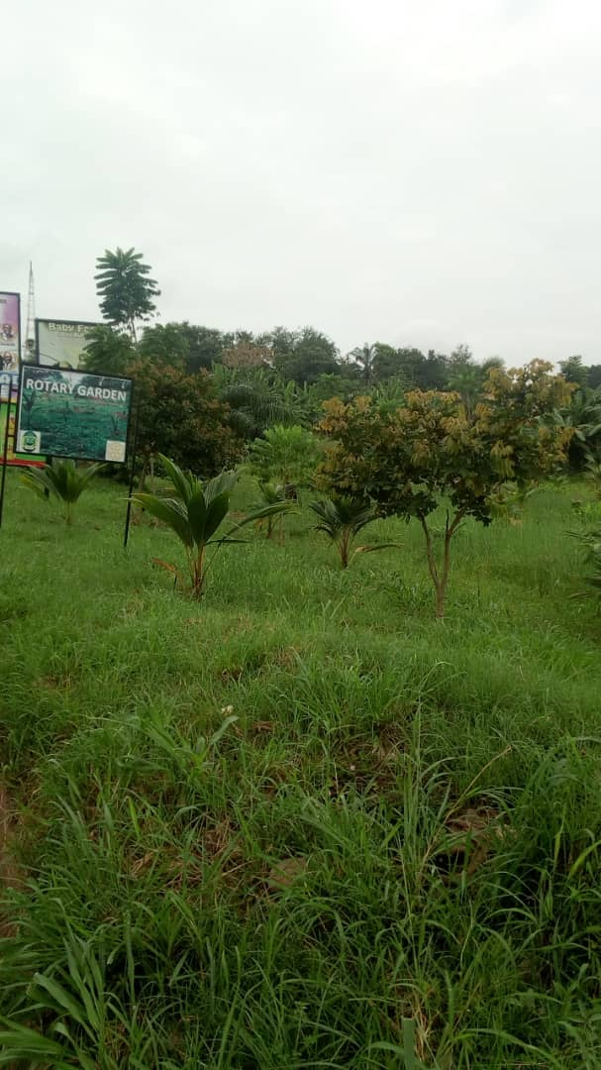 |  | 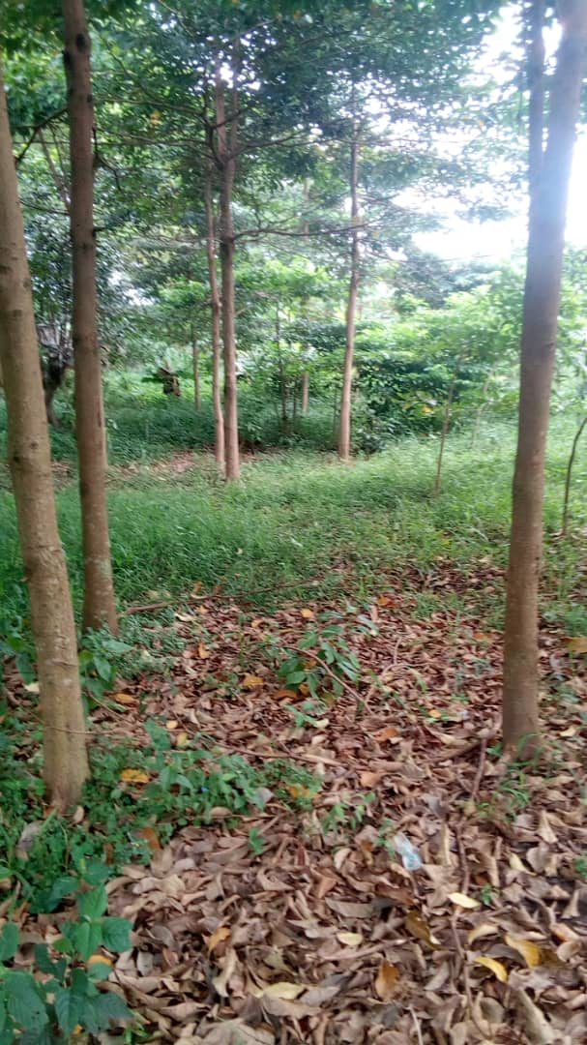
 | Figure 1:Coconut Plantation At Kma Clinic |  | Figure 2: Ofram, Mahogany & Emire Plantation At Ahodwo Roundabout

- Furnished Circuit Court at Adum
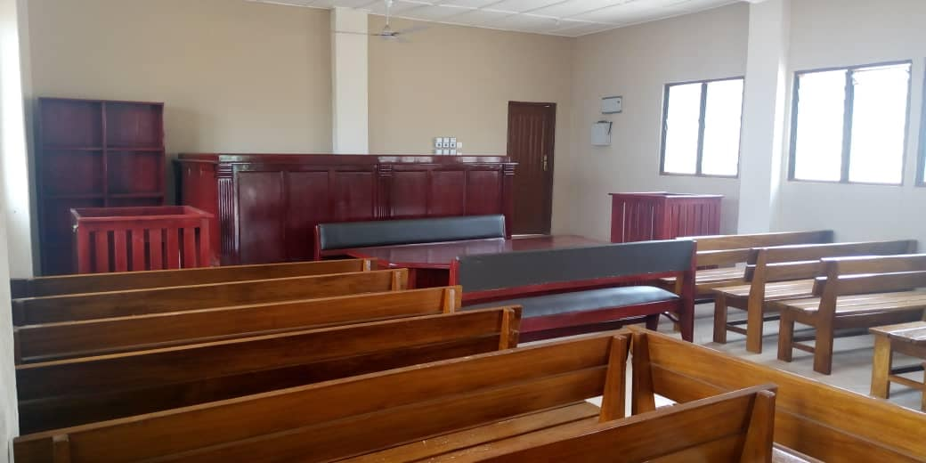
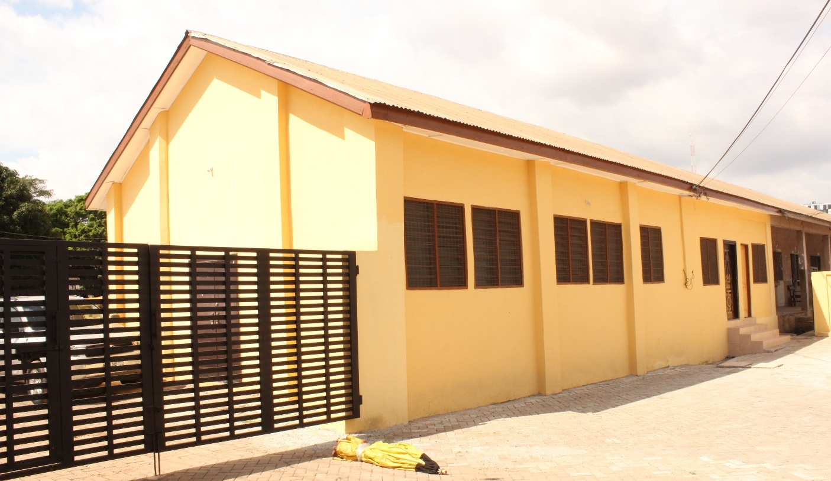
Figure 3: Furnished Circuit Court Building At Adum

3. Constructed and Furnished Kindergarten Block at Amakom
Figure 4: 1No. KG Block at Amakom

- 1 No. Borehole with Overhead Tanks (Rambo 400) at Boukrom Market
Figure 5: Mechanized Borehole With An Overhead Tank at Boukrom

5. 4 No. 10 Seater Institutional Toilets with Mechanised Borehole and Overhead tank
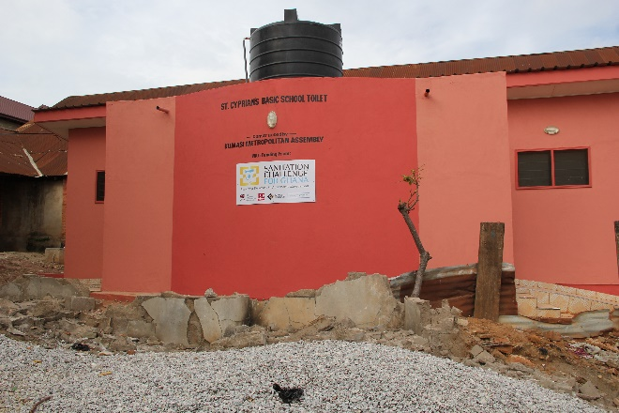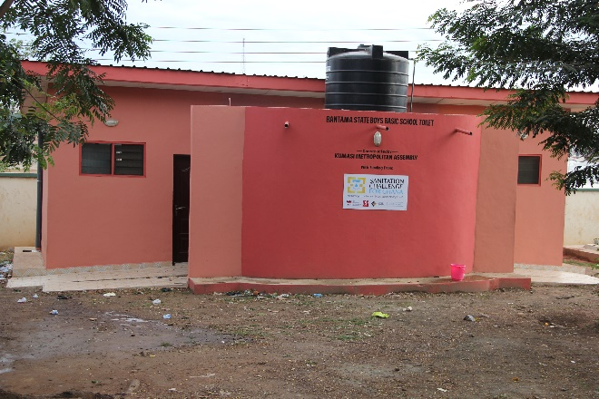
Figure 6. 10-seater institutional toilet at St. Cyprians Basic School
Figure 7. 10-seater institutional toilet at Bantama State Boys Basic School

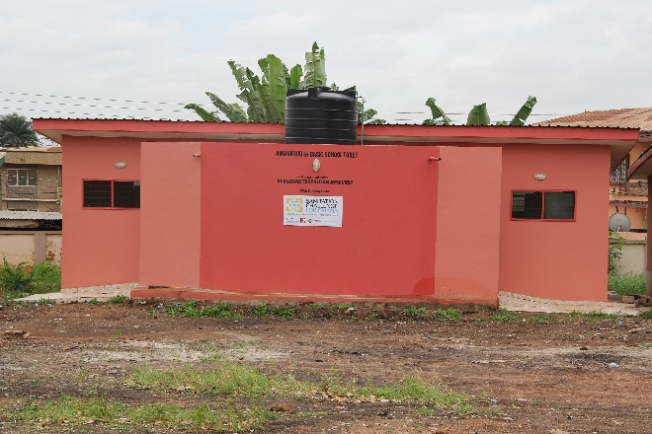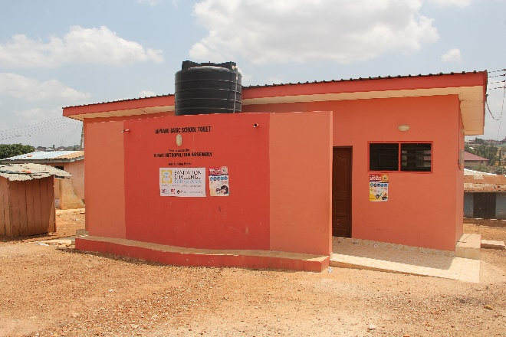
Figure 9. 10-seater institutional toilet at Anyaano Basic School
Figure 8. 10-seater institutional toilet at Amankwatia Basic School

- Pump House and Additional Headworks at Oti Landfill Site.
 | 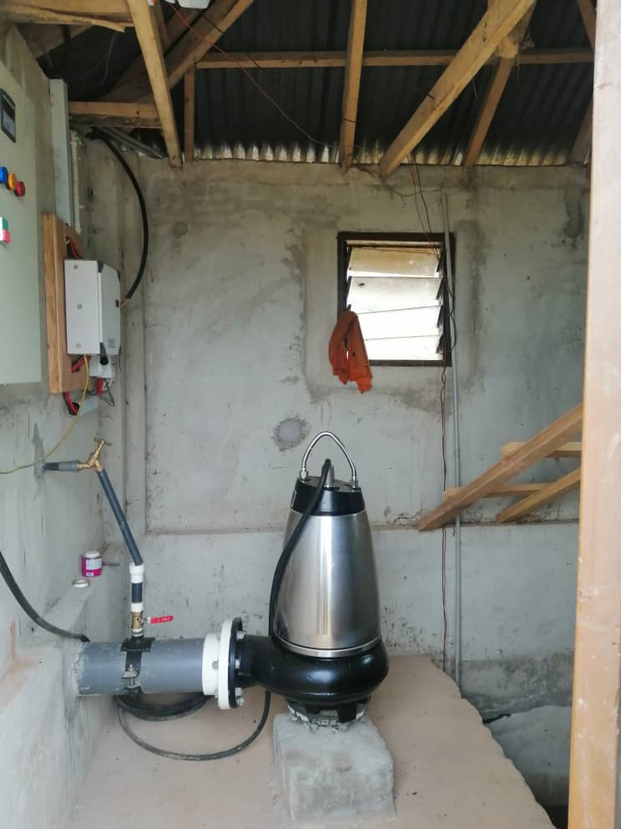 |  | 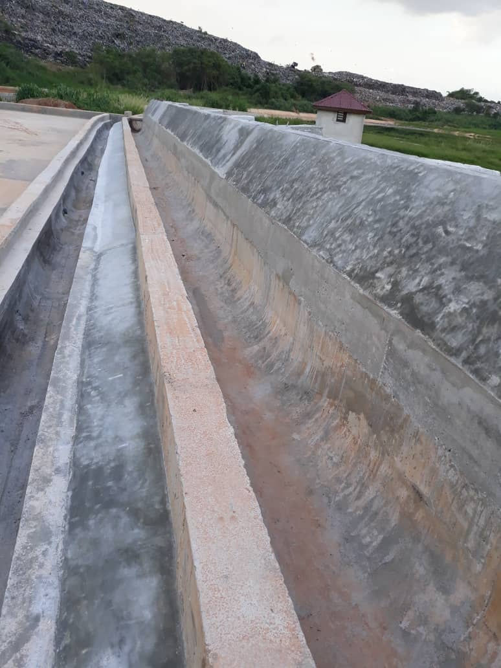
 | Figure 10: Installed Pump to Transfer Faecal Sludge |  | Figure 11: Additional Works On the Headworks for Faecal Sludge Discharge
- Constructed 1Km Haul Road to the Liquid Waste Treatment System at Oti
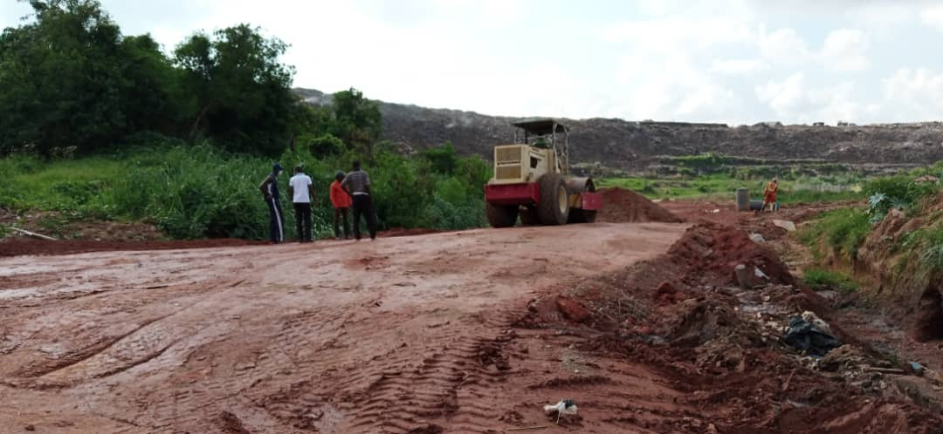
Figure 12: 1Km Haul Road to the Liquid Waste Treatment System at Oti
- New Nhyiaeso Sub Metro Office
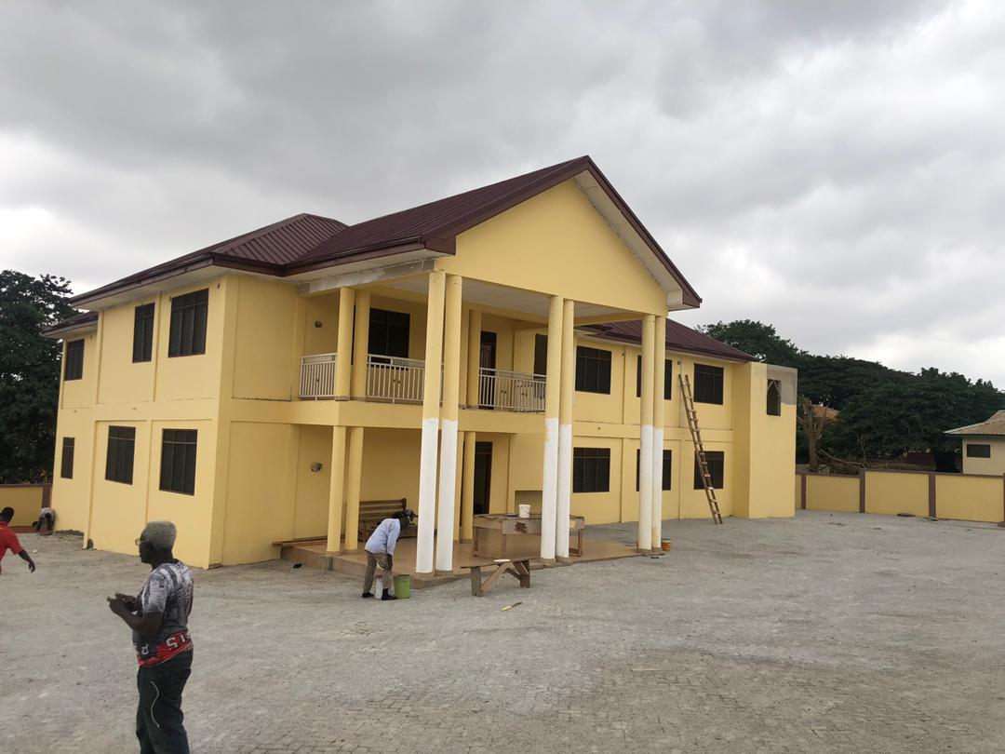
Figure 13: Constructed Nhyiaeso Sub-Metro Office at Fankyenebra.

8. FINANCIAL PERFORMANCE FOR 2020
a. IGF REVENUE PERFORMANCE

Table 1: IGF Revenue performance from 2018 to August, 2020
ITEM | 2018 |  | 2019 |  | 2020
 | Budget | Actual as at 31/12/18 | Budget | Actual as at 31/12/19 | Budget | Actual as at | %
 |  |  |  |  |  | Aug. 2020
Rates | 3,422,570.74 | 1,517,261.07 | 3,282,478.96 | 3,038,659.92 | 3,070,000.00 | 1,498,826.95 | 48.82
Fees | 8,575,096.00 | 8,680,625.75 | 9,926,000.00 | 9,305,251.94 | 9,771,700.00 | 6,084,385.75 | 62.27
Fines | 1,722,100.00 | 1,956,568.00 | 1,090,000.00 | 998,434.21 | 207,000.00 | 79,104.62 | 38.21
Licenses | 7,676,395.13 | 6,253,479.19 | 8,764,521.04 | 8,140,415.57 | 8,523,000.00 | 4,568,131.18 | 53.60
Land | 1,512,000.00 | 1,158,940.38 | 633,000.00 | 602,357.68 | 453,000.00 | 362,335.78 | 79.99
Rent | 546,000.00 | 533,501.83 | 950,000.00 | 1,464,138.45 | 825,000.00 | 445,534.28 | 54.00
Miscellaneous | 80,000.00 | 1,916,005.00 | 250,000.00 | 192,724.35 | 250,300.00 | 139,795.23 | 55.85
Total | 23,534,161.87 | 22,016,381.22 | 24,896,000.00 | 23,741,982.12 | 23,100,000.00 | 13,178,113.79 | 57.05
Table 1 above indicates that IGF revenue performance of 2018 and 2019 were 93.55% and 95.36% of the estimated respectively. The Assembly had realized an amount of GH¢13,178,113.793 out of the 2020 target of GH¢23,100,000 representing 57.05% as at August, 2020.

b. REVENUE PERFORMANCE – ALL REVENUE SOURCES
Table 2: Revenue performance from 2018 to August, 2020
REVENUE PERFORMANCE - ALL REVENUE SOURCES
ITEM | 2018 |  | 2019 |  | 2020 |  | % Perf. as at Aug. 2020
 | Budget | Actual | Budget | Actual | Budget | Actual as at Aug.
IGF | 23,534,161.87 | 22,016,381.22 | 24,896,000.00 | 23,741,982.12 | 23,100,000.00 | 13,178,113.79 | 57.05
Compensation Transfer | 13,648,423.00 | 13,080,423.00 | 9,915,426.54 | 8,402,792.13 | 11,882,023.01 | 7,921,342.25 | 66.67
Goods and Services Transfer | 489,326.69 | 424,400.24 | 96,769.47 | 13,797.13 | 105,395.83 | 96,321.12 | 91.39
Assets Transfer
DACF | 8,000,220.00 | 4,271,945.92 | 6,759,439.00 | 3,742,974.49 | 8,846,799.28 | 2,207,198.36 | 24.95
MPs CF & SIF | 3,380,000.00 | 3,128,658.10 | 1,600,000.00 | 2,102,105.05 | 2,269,359.71 | 1,270,460.00 | 55.98
PWD | 359,386.20 | 148,052.85 | 352,000.00 | 250,177.63 | 442,339.96 | 56,675.48 | 12.81
UDG | 24,614,435.03 |  |  |  | - | -
DDF (DACF-RFG) | 18,790,966.00 | 2,883,626.00 | 10,608,919.32 | 1,606,709.28 | 844,615.38 | 237,815.30 | 28.16
World Bank - Sanitation Challenge |  |  |  | 772,452.00 | 2,600,000.00 | 2,388,998.77 | 91.88
World Bank - AFD |  |  |  | 2,760,000.00 | 2,739,400.00 | 261,395.40 | 9.54
World Bank - GKMA |  |  |  |  | 5,000,000.00 | - | -
UNICEF |  |  |  |  | 70,000.00 | 66,443.00 | 94.92
MAG | 75,000.00 | 44,663.84 | 67,459.78 | 67,459.78 | 67,459.78 | 102,421.97 | 151.83
GUMPP | 1,780,000.00 | 552,394.74 | 1,000,000.00 | - | - | - | -
Stool Land Transfers | 200,000.00 | 692,000.00 | 700,000.00 | 941,858.33 | 900,000.00 | 739,465.55 | 82.16
Total | 94,871,918.79 | 47,242,545.91 | 55,996,014.11 | 44,402,307.94 | 58,867,392.95 | 28,526,650.99 | 48.46

Table 2 above illustrates the total revenue performance of the Assembly for the period. The total revenue performance stood at 49.80% and 79.30% for 2018 and 2019 respectively. As at August, 2020, actual total revenue was GH¢28,526,650.99 which represented 48.46% of the estimates for the year. Out of this amount, IGF contributed GH¢13,178,113.79 while the remaining amount of GH¢15,348,537.20 was received from Grants.

c. EXPENDITURE PERFORMANCE – IGF

Table 3: IGF Expenditure performance from 2018 to August, 2020
 | 2018 (GH¢) |  | 2019 (GH¢) |  | 2020 (GH¢) |  | %  PERF
ITEM | BUDGET | ACTUAL | BUDGET | ACTUAL | BUDGET | ACTUAL AS AT AUGUST 2020
COMPENSATION | 6,144,500.00 | 6,575,795.58 | 3,632,875.28 | 3,236,378.16 | 4,954,583.49 | 3,417,928.01 | 68.99
GOODS &SERVICES | 12,784,661.87 | 12,719,025.46 | 15,423,124.72 | 16,543,369.62 | 12,355,416.51 | 8,091,060.84 | 65.49
ASSETS | 4,605,000.00 | 2,716,761.90 | 5,840,000.00 | 3,962,234.34 | 5,790,000.00 | 1,653,377.00 | 28.56
TOTAL | 23,534,161.87 | 22,011,582.94 | 24,896,000.00 | 23,741,982.12 | 23,100,000.00 | 13,162,365.85 | 56.98

Table 3 above shows IGF expenditure performance stood at 93.53% and 95.36% for 2018 and 2019 respectively. As at August, 2020, actual IGF expenditure was GH¢13,162,365.85 which represented 56.98% of the IGF estimates of GH¢23,100,000.00.

d. TOTAL EXPENDITURE PERFORMANCE
Table 4: expenditure performance from all sources
ITEM | 2018 |  | 2019 |  | 2020 | 2020 | Perf. %
 | BUDGET | ACTUAL | BUDGET | ACTUAL | BUDGET | ACTUAL AS AT AUGUST
COMPENSATION | 19,792,923.00 | 19,655,817.84 | 13,548,302.22 | 11,639,170.29 | 16,836,606.50 | 11,339,270.26 | 67.35
GOODS & SERVICES | 20,515,458.87 | 16,196,671.13 | 20,292,133.70 | 19,027,377.01 | 20,892,570.78 | 11,201,731.46 | 53.62
ASSETS | 54,563,536.92 | 11,385,258.66 | 22,155,578.19 | 13,732,320.34 | 21,138,215.67 | 6,401,777.45 | 30.29
TOTAL | 94,871,918.79 | 47,237,747.63 | 55,996,014.11 | 44,398,867.64 | 58,867,392.95 | 28,942,779.17 | 49.17

As at August, 2020, actual expenditure from all sources was GH¢28,942,779.17 which represented 49.17% of the overall budget of GH¢58,867,392.95. This amount is distributed to the programmes as indicated in table 5.

- 2020 PERFORMANCE BY PROGRAMMES

Table 5 : 2019 Expenditure Performance by Programmes
NO. | NAME OF BUDGET PROGRAMME | BUDGET (GH¢) | ACTUAL AS AT August, 2020 (GH¢) | PERCENTAGE PERFORMANCE
1. | MANAGEMENT AND ADMINISTRATION | 16,956,531.10 | 9,336,858.67 | 55.06
2. | INFRASTRUCTURE DELIVERY AND MANAGEMENT | 8,656,642.15 | 3,256,130.08 | 37.61
3. | SOCIAL SERVICES DELIVERY | 11,627,863.94 | 6,716,962.84 | 57.77
4. | ECONOMIC DEVELOPMENT | 6,825,595.25 | 2,355,876.42 | 34.52
5. | ENVIRONMENTAL AND SANITATION MANAGEMENT | 7,816,822.75 | 4,943,223.95 | 63.24
6. | BUDGET AND FINANCE | 6,983,937.76 | 2,333,727.21 | 33.42
TOTAL |  | 58,867,392.95 | 28,942,779.17 | 49.17

9. ADOPTED POLICY OBJECTIVES IN LINE WITH SDGs, TARGETS AND COST
Table 6: Adopted Policy Objectives
FOCUS AREA | POLICY OBJECTIVE | BUDGET
ECONOMIC DEVELOPMENT | 1. Strengthen domestic revenue mobilisation | 1,758,286.09
 | 2. Improve production efficiency and yield
 | 3.Devise and implement policies to promote sustainable tourism that creates jobs
SOCIAL DEVELOPMENT | 4. Ensure free equitable and quality education for all by 2030 | 27,141,485.76
 | 5. Improve safe and reliable water supply services for all
 | 6. Implement appropriate social protection systems and measures
 | 7. Achieve universal health coverage including financial risk protection access to quality health care service
GOVERNANCE, CORRUPTION & PUBLIC ACCOUNTABILITY | 8. Deepen political and administrative decentralization | 17,870,299.56
 | 9. Devise and implement policies to promote sustainable tourism that creates jobs
 | 10. Promote inclusive and sustainable industrialization
ENVIRONMENT, INFRASTRUCTURE & HUMAN SETTLEMENT | 11. Facilitate sustainable and resilient infrastructure development | 27,412,028.59
 | 12. Enhance inclusive urbanisation and capacity for settlement planning
 | 13. Improve transport and road safety
 | 14. Sanitation for all and no open defecation by 2030
 | 15. Inclusive settlements implementing inter climate change and disaster risk reduction
 | 16. Integrate climate change measures
TOTAL |  | 74,182,100.00

10. POLICY OUTCOME INDICATORS AND TARGETS

Table 7: Policy Outcome Indication and Target
Outcome Indicator Description | Unit of Measurement | Baseline |  | Latest status |  | Target
 |  | Year | Value | Year | Value Aug. 2020 | Year | Value
Improved financial management | Percentage growth in IGF | 2019 | 7.86 | 2020 | (17.77) | 2021 | 12.50
 | % of expenditure performance | 2019 | 79.29 | 2020 | 49.17 | 2021 | 90
Enhanced capacity of staff | % of staff equipped with relevant skills | 2019 | 65 | 2020 | 40 | 2021 | 70
Enhanced Agriculture productivity | Number of farmers trained in improved technologies | 2019 | 322 | 2020 | 199 | 2021 | 450
Improved access to sanitation | Proportion of wastes properly disposed of at public disposal site. | 2019 | 80 | 2020 | 90 | 2021 | 95
 | Number of households with improved sanitation facilities | 2019 | 5,688 | 2020 | 7,350 | 2021 | 10,000
Improved natural resource conservation | Number of trees planted and protected | 2019 | 17,245 | 2020 | 11,150 | 2021 | 35,000
Improved access to safe drinking water | % of population with access to potable water | 2019 | 85 | 2020 | 95 | 2021 | 100
Reduced congestion and shift system at the basic school level | Number of schools under shift system | 2019 | 6 | 2020 | 4 | 2021 | 5
Improved access to quality healthcare | Percentage of population accessing health services | 2019 | 90 | 2020 | 95 | 2021 | 99
Fiscal, political and administrative functions of Assembly improved | Performance assessment score in FOAT/DPAT | 2019 | 97 | 2020 | 98 | 2021 | 100
Enhanced participation, transparency and accountability. | Percentage of stakeholders sensitized on Local governance | 2019 | 80 | 2020 | 85 | 2021 | 100
Improved Projects and Programmes Implementation | Percentage of Annual Action Plan (AAP) Implemented | 2019 | 90 | 2020 | 94 | 2021 | 100
Table 1 above indicates the policy outcome indicators of the Assembly using 2019 as the baseline year, 2020 as the current performance and 2021 as the target.

11. REVENUE MOBILIZATION STRATEGIES FOR MAJOR REVENUE SOURCES
Major revenue source for Kumasi Metropolitan Assembly include Property Rate, Revenue from Market (toll and rent), On-Street Parking and Lorry Park, Business Operating Permit, Building/Development Permits, Rattray Park among others. Strategies for enhancing revenue from these sources are;

Table 8: Revenue Mobilization Strategies
S/N | REVENUE ITEM | STRATEGY
1 | Property Rate | Complete the revaluation of properties by the first quarter of 2021. The street naming and property addressing project is to be fully completed by end of year, 2020. The full implementation of a revenue collecting and tracking software (dLRev) to churn out reports on all property addresses that are paid-up or defaulted in real-time for necessary action is to be rolled out in 2021. Property rate Improvement Team formed
2 | Market Toll / Lorry Park Tolls & On-Street Parking | Toll collection would be collected wholly with a Point of sale (PoS) device hooked on to the revenue software to address leakages. This will be supported with a monitoring team that would be alternated every other day.
3 | Rent | All stores data/records of the Assembly are to be updated on the revenue software for effective monitoring on payments.
4 | Business operating Permit | The revenue items have been shared amongst Sub-Metros, Outsourced Revenue Collecting Companies and Main Assembly. This has been tied to a performance measure. Monitoring will be intensified.
5 | Building & development Permits | Increased statutory meetings for permitting purposes. All payments are to be made at the banks by Ratepayers. Development control Task Force formed and resourced
6 | Rattary Park / Investment in Amusement Parks | The Park has undergone a major facelift with amenities that attracts and entertains both the young and old. The throughput increased in the first quarter of 2020 but slowed significantly due to the effects of Covid-9 pandemic. The Assembly continues to partner the contractor in planning attractive packages to grow revenues as well as enhancing the monitoring of activities at the Park.

PART B: PROGRAMME 1: MANAGEMENT AND ADMINISTRATION
BUDGET PROGRAMME OBJECTIVES
Objectives of this programme are;
- To integrate and institutionalize planning and budgeting through participatory process
- To strengthen and operationalize the sub district structures and ensure consistency with Local Government laws.
- To provide legislative oversight responsibilities for the Assembly , Sub-district structures and other agencies
- To provide efficient human resource management of the Assembly
- Ensure full political, administrative and fiscal decentralization
BUDGET PROGRAMME DESCRIPTION
The program seeks to perform the core functions of ensuring good governance and balanced development of the District through the formulation and implementation of policies, planning, coordination, monitoring and evaluation in the area of local governance. The Program is being implemented and delivered through the offices of the Central Administration and Legal Departments. The various units involved in the delivery of the program include; General Administration Unit, Planning Unit, Procurement Unit, Human Resource and Records Unit. It seeks to provide administrative and logistic support services for the smooth operation of other departments and Sub-Metropolitan councils.
The programme is mainly delivered by the Central Administration and Legal Departments. The various units involved with the delivery of the programme include;
- General Administration
- Planning and Coordination Unit
- Human Resource Unit
- Legal Department
- Metropolitan/City Guards (Security)
The programme is being implemented with the total support of all staff of the Central Administration, Human Resource and the Legal Department totaling four hundred and sixty-five (465). They include Administrators, Planners, Human Resource Managers, Lawyers, Metro Guards, Executive Officers, Drivers, Cleaners and Laborer’s.
The programmme is to be funded with transfers from the Central Government (sector specific transfers and salaries), District Assembly Common Fund (DACF), Donor funds, District Development Facility (DDF) and the Internally Generated fund – IGF.

BUDGET SUB-PROGRAMME SUMMARY
PROGRAMME 1: MANAGEMENT AND ADMINISTRATION

SUB PROGRAMME SP1.1: GENERAL ADMINISTRATION
- Budget Sub-Programme Objective
The objectives of the General Administration sub program are;
- Ensure full political, administrative and fiscal decentralization
- Budget Sub Programme Description
The General Administration sub-programme looks at the provision of administrative support and effective coordination of the activities of the various departments through the Office of the District Co-ordinating Director. The sub-programme is responsible for all activities and programmes relating to general services, internal controls, procurement/stores, transport, public relation and security.
The core function of the General Administration unit is to facilitate the Assembly’s activities with the various departments, quasi institution, and traditional authorities. In addition, the Metropolitan Security Committee (MESEC) is mandated to initiate and implement programmes and strategies to improve public security in the Metropolis.
Under the sub-programme the procurement processes of Goods and Services and Assets for the Assembly and the duty of ensuring inventory and stores management is being led by the Procurement/Stores Unit.
Activities under this sub programme include training and development of staff through capacity building programmes, payment of utilities, strengthening of sub district structures, general maintenance of Assembly property, provision of financial assistance to the public and supply of office equipment and facilities. Organizing statutory programmes, public sensitization programmes just to mention a few.
This sub-programme is carried out by mainly by the Central Administration Department and units as well as the Sub Metropolitan Councils of the Assembly.
The sources of funds of this sub programme are internally generated fund, District Assemblies’ Common Fund and transfers from Central Government.
Beneficiaries of the sub programme are the staff of the Assembly and the general public. The challenges include inadequate funds and logistics.
A total staff strength of three hundred and twenty one (321) is expected to ensure the implementation of this sub-programme.
- Budget Sub-Programme Results Statement
The table indicates the main outputs, its indicators and projections by which the performance of this sub-programme is measured. The past data indicates actual performance whilst the projections are the estimates of future performance.
Table 9: Budget Sub-Programme Results Statement
Main Output | Output Indicator | Past Years |  | Projections
 |  | 2019 | 2020 (Aug) | Budget Yr. 2021 | Indicative Yr. 2022 | Indicative Year 2023 | Indicative Yr. 2024
Annual progress report prepared | Submission date | 7/2/20 | 8/2/21 | 7/2/22 | 8/2/23 | 8/2/24 | 5/2/25
Statutory meetings organized | Number of meetings held | 32 | 18 | 40 | 40 | 40 | 40
Town hall meetings organized | No of Town Hall meetings organized | 3 | 2 | 4 | 4 | 4 | 4
Management/HOD meetings held | No. of HODs meetings held | 10 | 4 | 12 | 12 | 12 | 12
Sub-metro Councils functional | No. of Sub-metros functional | 5 | 5 | 5 | 5 | 5 | 5
Entity Tender Committees Meetings Held | No. of Entity Tender Board meetings held | 12 | 5 | 12 | 12 | 12 | 12
Composite Annual Action Plan prepared | Date of approval | 28/9/18 | 27/9/19 | 24/9/20 | 23/9/21 | 27/9/22 | 27/9/23

- Budget Sub-Programme Operations and Projects
The table lists the main Operations and Projects to be undertaken by the sub-programme.
Table 10: Operations and Project
Operations | Projects (Investment)
Internal management of the organization | Procure Computers and Accessories
Information, Education and Communication | Procure 2No. Pick Up Trucks and 1No. Toyota Dyna Vehicles
Promoting citizens participation in Local Governance | Decongestion and Slum Development
Manpower skills development
Gender Related Activities

SUB PROGRAMME SP1.2: Planning and Coordination
- Budget Sub-Programme Objective
The objectives of this sub program are to
- To integrate and institutionalize planning and budgeting through participatory process
- To ensure monitoring and evaluation of all development projects and programmes.
- Budget Sub Programme Description
The sub-programmes coordinate policy formulation, preparation and implementation of the District Medium Term Development Plan and Monitoring and Evaluation Plan. The main unit for the delivery is the Planning Unit. The main sub-program operations include;
- Preparing and reviewing District Medium Term Development Plans and Monitoring & Evaluation Plans.
- Co-ordinate and develop annual action plans, monitor and evaluate programmes and projects
- Periodic monitoring and evaluation of entire operations and projects of the Assembly to ensure compliance of rules, value for money and enhance performance.
- Organizing stakeholder meetings, public forum and town hall meetings

A total staff strength of six (6) would be expected to carry out this Sub programme.
IGF and DACF are the major sources of funds for Planning and Coordination sub-programme, the challenges being the untimely releases of funds and inadequate logistics.
The beneficiary of the sub-programme is the Assembly.

- Budget Sub-Programme Results Statement
Table 11: Budget Sub-Programme Results Statement
Main Output | Output Indicator | Past Years |  | Projections
 |  | 2019 | 2020 | Budget Year 2021 | Indicative Year 2022 | Indicative Year 2023 | Indicative Year 2024
MPCU meetings organized | Number of meetings held | 4 | 3 | 4 | 4 | 4 | 4
Annual Action Plan prepared | Date of approval | 28/9/18 | 27/9/19 | 26/10/20 | 23/09/21 | 27/09/23 | 24/09/24
Monitoring and Evaluation of projects | Number of monthly monitoring visits organised | 12 | 6 | 12 | 12 | 12 | 12
Below are the main outputs, indicators and projections by which the Assembly measures performance of this sub-programme.

- Budget Sub-Programme Operations and Projects
The table lists the main Operations and Projects to be undertaken by the sub- programme.
Table 12: Operations and Projects
Operations | Projects (Investment)
Internal management of the organization
Planning and policy formulation
Procurement of office supplies and consumables

PROGRAMME 1: MANAGEMENT AND ADMINISTRATION

SUB PROGRAMME SP1.3: Legal
1. Budget Sub-Programme Objective
The objective of this sub program is to provide adequate legal services to support the effective and efficient implementation of policies and programmes of the Assembly and provide legislative oversight responsibilities for the Assembly, Sub-structures and other agencies.
2. Budget Sub Programme Description
This Sub-programme provides adequate technical and logistical support to enhance legal performance of the Assembly. It also ensures that all agreements, contracts and engagements of the Assembly are undertaken in accordance with the required legal provisions and policies to ensure the desired results are achieved.
Among the activities undertaken through this Sub-programme are provision of logistics and building the capacities of the Metro Guards to enhance their performance. It also supervises the marriage registry.
This Sub-programme is carried out by the Legal Department of the Assembly. It is expected that a total number of one hundred and thirty eight (138) staffs will carry out this sub programme.
The funding sources of this sub-programme include Internally Generated Fund, District Assemblies Common Fund and District Development Fund.
Beneficiaries of this sub programme include the Judicial Service, civil society groups, business community, transport organisations, Churches, pedestrians, security services and the general public.

3. Budget Sub-Programme Results Statement
Below are the main outputs, indicators and projections by which the Assembly measures performance of this sub-programme.

Table 13: Budget Sub-Programme Results Statement
Main Output | Output Indicator | Past Years |  | Projections
 |  | 2019 | 2020 | Budget Year 2021 | Indicative Year 2022 | Indicative Year 2023 | Indicative Year 2024
Capacity of Metro Guards enhanced | Number of metro guards trained and clothed | 47 | 30 | 50 | 50 | 50 | 50
Police stations upgraded | Number of Police station facilities constructed | 1 | 0 | 2 | 1 | 1 | 1
Courts constructed or rehabilitated | Number of Courts renovated | 1 | 1 | 1 | 1 | 1 | 1
MESEC Meetings Organised | Number of MESEC meetings held | 10 | 12 | 10 | 10 | 10 | 10

4. Budget Sub-Programme Operations and Projects
The table lists the main Operations and Projects to be undertaken by the sub- programme.

Table 14: Operations and Projects
Operations | Projects (Investment)
Internal Management of the Organisation | Construction of 1No. Police Station at Asafo
Acquisition of immovable and movable assets | Construct 1No. Police Quarters at Subin
 | Construct 1No. Environmental Court at Bantama

BUDGET SUB-PROGRAMME SUMMARY

PROGRAMME1: Management and Administration

SUB-PROGRAMME 1.4 Human Resource Management

- Budget Sub-Programme Objective
- To achieve institutional performance goals that are linked to the individual and team performance objectives, as the basis for measuring performance results and merit.
- To provide Human Resource Planning and Development of the Assembly.
- To develop capacity of staff to deliver quality services.

- Budget Sub-Programme Description

The Human Resource Management seeks to improve the departments, division and unit’s decision making and build capacity of the manpower which will ultimately improve the workforce and organizational effectiveness. In carrying out this sub-programme it is expected that productivity would be enhanced at the Assembly as well as decision making in the management of Human Resource.

Major services and operations delivered by the sub-program include human resource auditing, performance management, service delivery improvement, upgrading and promotion of staff. It also includes Human Resource Management Information System which ensures frequent update of staff records through electronic means, guaranteeing efficient and good salary administration, facilitation of recruitment and selection as well as postings of competent staff to fill available vacancies at the district.

Eight (8) staffs will carry out the implementation of the sub-programme with main funding from GoG transfer, DACF-RFG and Internally Generated Fund. The work of the human resource management is challenged with limited logistics. The sub-programme would be beneficial to staff of the Departments of the Assembly, Local Government Service Secretariat and the general public.

- Budget Sub-Programme Results Statement
The table indicates the main outputs, its indicators and projections by which the District Assembly’s measure the performance of this sub-programme. The past data indicates actual performance whilst the projections are the Assembly’s estimate of future performance.

Main Outputs | Output Indicator | Past Years |  | Projections
 |  | 2019 | 2020 | Budget Year  2021 | Indicative Year  2022 | Indicative Year  2023 | Indicative Year  2024
Appraisal of staff annually | Number of staff appraisal conducted | 450 | 355 | 650 | 650 | 650 | 650
Administration of Human Resource Management Information System (HRMIS) | Number of updates and submissions | 12 | 8 | 12 | 12 | 12 | 12
Prepare and implement capacity building plan | Composite training plan approved by | 31st Dec. | 31st Dec. | 31st Dec. | 31st Dec. | 31st Dec. | 31st Dec.
 | Number of training workshop held | 4 | 4 | 3 | 3 | 3
Salary Administration | Monthly validation ESPV | 12 | 8 | 12 | 12 | 12 | 12

- Budget Sub-Programme Operations and Projects
The table lists the main Operations and projects to be undertaken by the sub-programme

Operations |  | Projects
Personnel and Staff Management

PROGRAMME 2: INFRASTRUCTURE DELIVERY AND MANAGEMENT
Budget Programme Objectives
The objectives of this programme are to;
- Develop human and institutional capacities for land use planning
- Promote resilient urban infrastructural development & maintenance, and basic service provision.
- Ensure sustainable development and management of the transport sector
- To accelerate the provision of affordable and safe drinking water
Budget Programme Description
This Sub-Program provides basic infrastructure support such as housing, roads and energy. It involves the expansion of good road network, acceleration of ongoing road projects and provision of awareness creation on safe driving practices.
The programme is mainly delivered by the Works, Urban Roads and Physical Planning Departments. The various units involved with the delivery of the program include;
- Works Department
- Town & Country Department and Parks and Gardening
- Urban Roads Department
The programme is being implemented with the total staff of one hundred and sixty-one (161). They include Engineers, Architects, Technicians, Planners, Drivers, Cleaners and Labourers.
The program involves three (3) Sub-programmes. These include
- Public Works Service
- Urban Roads Management
- Physical and Spatial Planning Development

The programmme is to be funded with transfers from the Central Government (sector specific transfers, salaries) District Assembly Common Fund (DACF), Donor funds (e.g GIZ), District Development Facility (DDF) and the Internally Generated fund – IGF.
The beneficiaries of this programme are Road Users, Estate Developers, Traditional Authorities, Land Owners, Contractors, Public Infrastructure users and the general public.
PROGRAMME 2: INFRASTRUCTURE DELIVERY AND MANAGEMENT

SUB PROGRAMME SP2.1: Public Works Service
- Budget Sub-Programme Objective
The objectives of this sub program are to;
- Facilitate sustainable and resilient infrastructure development & maintenance, and basic service provision.
- Implement integrated water resources management
- Budget Sub Programme Description
The sub-programme is tasked with the responsibility of developing and implementing appropriate strategies and programmes that aims to improve the living conditions of rural dwellers through efficient infrastructures relative to housing and water supply. The department of Works comprising of former Public Works and Rural Housing Department is delivering the sub-programme. The sub-program operations include;
- Facilitating the implementation of policies on works and report to the Assembly
- Assisting to prepare tender documents for all civil works projects to be undertaken by the Assembly through contracts or community initiated projects.
- Facilitating the construction, repair and maintenance of public buildings and drains along any streets in the major settlements in the Metropolis.
- Facilitating the provision of adequate and wholesome supply of potable water for the entire Metropolis.
- Assisting in the inspection of projects undertaken by the District Assembly with relevant Departments of the Assembly.
- Provide technical and engineering assistance on works undertaken by the Assembly.
The Public Works Service sub programme is carried out with a total staff strength of one hundred and eleven (111).The beneficiaries of this sub programme are Assembly staff, property owners and the general public. The sources of fund for this sub programme are IGF, DACF, DDF and UDG. The challenges include inadequate funds and untimely releases.

- Sub-Programme Results Statement
The table below indicates the main outputs, its indicators and projections by which the Assembly measures the performance of the sub programme;

Table 15: Sub-Programme Results Statement
Main Output | Output Indicator | Past Years |  |  | Projections
 |  | 2019 | 2020 | Budget Year 2021 | Indicative Year 2022 | Indicative Year 2023 | Indicative Year 2024
Construction and renovation of Assembly Properties | Number of properties renovated/constructed | 8 | 5 | 10 | 10 | 15 | 15
Provision of street bulbs | No of bulbs replaced | 600 | 500 | 1000 | 1000 | 1000 | 1000
Provide mechanized boreholes | No of mechanized boreholes provided | 10 | 5 | 10 | 15 | 20 | 20

- Budget Sub-Programme Operations and Projects
The table lists the main Operations and Projects to be undertaken by the sub- programme.
Table 16: Operations and Projects
Operations | Projects (Investment)
Acquisition of immovable and movable Assets | Construction of office accommodation for Sub-Metros
Routine Monitoring of programmes and projects | Maintenance and provision of Streetlights & electrical equipments in the Kumasi Metropolis
Development and Management of water systems | Rehabilitate Assembly’s Markets & Bungalows
 | Construct 10No. Mechanised Boreholes.
 | Paving of 1No. Event ground at Odeneho Kwadaso
 | Construct 1No. Community/Social Centre at Abrepo Junction

PROGRAMME 2: INFRASTRUCTURE DELIVERY AND MANAGEMENT

SUB PROGRAMME SP2.2: Urban Roads Management
- Budget Sub-Programme Objective
The objectives of this sub program are to;
- Ensure sustainable development and management of the transport sector
- Budget Sub Programme Description
This Sub-Programme ensures the provision of good and accessible roads as well as the management of existing roads in the metropolis.
The activities undertaken through this sub progamme include the construction and maintenance of roads, storm drains, bridges and culverts.
With a staff strength of five (5), this sub programme is carried out by the Department of Urban Roads of the Assembly.
The sources of funds for this sub programme are; Internally Generated Fund, Central Government Transfers, District Assembly Common Fund, District Development and Road Fund.
The challenges that underpin this sub programme are inadequate funds, unreliable climatic condition and external interference from the public.
The general public are the beneficiaries of this sub programme.

Table 17: Budget Sub-Programme Description
Main Output | Output Indicator | Past Years |  | Projections
 |  | 2019 | 2020 | Budget Year 2021 | Indicative Year 2022 | Indicative Year 2023 | Indicative Year 2024
Sealing of Roads | Kilometer length of road improved | 0 | 3km | 5.7km | 10km | 10km | 10km
Construct u-drain | Number of km constructed | 0 | 6 | 8 | 8 | 8 | 8
Construct foot bridges | Number of footbridges constructed | 10 | 3 | 6 | 20 | 20 | 20
Resealing of Roads | Kilometer length of road resealed | 9.5km | 5.0km | 15km | 15km | 15km | 15km
Asphalting of Roads | Kilometer length of road asphalted | 12km | 35km | 80km | 80km | 80km | 80km
Construct culverts | Number of culverts constructed | 0 | 1 | 4 | 4 | 4 | 5
Roads Reshaped | Kilometer Length of roads reshaped | 0 | 0 | 50 | 50 | 50 | 50
- Sub-Programme Results Statement

The table above indicates the main outputs, its indicators and projections by which the Assembly measures the performance of the sub programme;

- Budget Sub-Programme Operations and Projects
The table lists the main Operations and Projects to be undertaken by the sub- programme.
Table 18: Operations and Projects
Operations | Projects (Investment)
Acquisition of immovable and movable Assets | Construct guard rails within major streets of the Central Business District (CBD)
Routine Monitoring of programmes and projects | Construct 2No. 0.4Km & 3No. 0.6Km u-drain
Internal Management of the Organisation | Construct 6No. Metal footbridges over drains/streams in selected communities
 | Construct 250m length of open storm drain at CPC & 500m & 1000m length of u-drain at Adiebeba & Danyame respectively
 | Construct 3No. culverts
 | Reconstruct outfall culvert at Subin Valley area
 | Pothole patching/sectional repairs and resealing of roads in Kumasi

PROGRAMME 2: INFRASTRUCTURE DELIVERY AND MANAGEMENT

SUB PROGRAMME SP2.3: Physical and Spatial Planning Development
1. Budget Sub-Programme Objective
The objective of this sub program is to
- Enhance inclusive urbanization and capacity for settlement planning.
2. Budget Sub Programme Description
The sub-programme seeks to co-ordinate activities and projects of departments and other agencies including non-governmental organizations to ensure compliance with planning standards. It also focuses on the landscaping and beautification of the Metropolis. The Physical and Spatial Planning sub-programme is delivered through the Department of Physical Planning and tasked to manage the activities of the former department of Town and Country Planning and the department of Parks and Gardens in the Metropolis.
Major services delivered by the sub-program include;
- Assist in the preparation of physical plans as a guide for the formulation of development policies and decisions and to design projects in the Metropolis.
- Advise on setting out approved plans for future development of land.
- Assist to provide the layout for buildings for improved housing layout and settlement.
- Advise the Assembly on the siting of bill boards, masts and ensure compliance with the decisions of the Assembly.
- Undertake street naming, numbering of house and related issues.
The sub programme is carried out by the Physical Planning Department with a staff strength of forty-five (45) to carry out the sub programme. The sources of funds for this sub programme are; Internally Generated Fund, Central Government Transfers, District Assembly Common Fund and GIZ support. The challenges of this sub programme are irregular and untimely release of transfers.
Property owners, Traditional Authorities, Estate Developers general public are the beneficiaries of this sub programme.

3. Sub-Programme Results Statement
The table below indicates the main outputs, its indicators and projections by which the Assembly measures the performance of the sub programme;

Table 19: Sub-Programme Results Statement
Main Output | Output Indicator | Past Years |  | Projections
 |  | 2019 | 2020 | Budget Year 2021 | Indicative Year 2022 | Indicative Year 2023 | Indicative Year 2024
Acquire legal title on Assembly land | Number of titles acquired | 0 | 1 | 5 | 5 | 5 | 5
Procure and install street signs | No. of poles procured and installed | 50 | 80 | 200 | 200 | 200 | 200

4. Budget Sub-Programme Operations and Projects
The table lists the main Operations and Projects to be undertaken by the sub- programme.
Table 20: Operations and Projects
Operations | Projects (Investment)
Acquisition of immovable and movable Assets | Procure and install street signs for street naming and property addressing project
Land use and spatial planning

PROGRAMME 3: SOCIAL SERVICES DELIVERY
Budget Programme Objectives
The objectives of this programme are to;
- Enhance inclusive & equitable access & participation in education at all levels
- Ensure sustainable, equitable and easily accessible healthcare services
- Establish an effective and efficient social protection system
- Ensure sanitation and hygienic environment.

Budget Programme Description
The social services delivery budget programme provides essential services in the areas of education, health, social intervention and community development. It ensures the provision of social amenities like educational infrastructure and health facilities.
It bridges gender and equity gaps in access to education and health care delivery, and ensure the reduction in STIs, TB and malaria and provide social protection to the vulnerable in society.
The programme is delivered by the Education, Youth and Sports, Health and Social welfare and Community Department. The various units involved with the delivery of the program include;
- Ghana Health Service and Environmental Health Unit
- Social Welfare & Community Development
- Education, Youth and Sports
The programme is being implemented with the total support of staff of Social Welfare & Community Development, Health and Education, Youth and Sports Departments.
The programme is to be implemented with a total staff strength of one hundred and eighty-three (183). They include Health Practitioners, Educationists, Social Workers and Sanitary Officers.
The program involves three (3) sub-programmes. These include
- Education, Youth and Sports
- Social Welfare and Community Development
- Health Service delivery.
The programmme is to be funded with transfers from the Central Government (sector specific transfers, District Assembly Common Fund (DACF), Donor funds, District Development Facility (DDF) and the Internally Generated fund (IGF).
This programme involves three (3) sub-programmes which seeks to:
- Enhance inclusive & equitable access & participation in education at all levels
- Bridge gender gap in access to education.
- Establish an effective and efficient social protection system
- Expand social protection interventions for the poor
- Promote effective child development in all communities
- Ensure effective appreciation of and inclusion of disability issues

PROGRAMME 3: SOCIAL SERVICES DELIVERY

SUB PROGRAMME SP3.1: Education, Youth and Sports Management
- Budget Sub-Programme Objective
- To formulate and implement policies on Education in the District within the framework of National Policies and guidelines.
- Increase access to education through school improvement.
- To improve the quality of teaching and learning in the District.
- Budget Sub-Programme Description

The Education and Youth Development sub-programme is responsible for pre-school, special school, basic education, youth and sports development or organization and library services at the District level. Key sub-program operations include;
- Advising the Assembly on matters relating to preschool, primary, junior high schools in the district and other matters that may be referred to it by the District Assembly.
- Facilitate the supervision of pre-school, primary and junior high schools in the District
- Co-ordinate the organization and supervision of training programmes for youth in the district to develop leadership qualities, personal initiatives, patriotism and community spirit.
- Advise on the provision and management of public libraries and library services in the district in consultation with the Ghana Library Board.
- Advise the Assembly on all matters relating to sports development in the District.

Organizational units delivering the sub-programme include the Ghana Education Service with funding from the GoG and Assembly’s Internally Generated Funds.

Major challenges hindering the success of this sub-programme includes delay and untimely release of funds, inadequate office space and logistics. Beneficiaries of the sub-programme are the general public.

- Sub-Programme Results Statement
The table indicates the main outputs, its indicators and projections by which the District Assembly measure the performance of this sub-programme. The past data indicates actual performance whilst the projections are the Assembly’s estimate of future performance;
Table 21: Sub-Programme Results Statement
 |  | Past Years |  | Projections
Main Outputs | Output Indicator | 2019 | 2020 | Budget Year  2021 | Indicative Year  2022 | Indicative Year  2023 | Indicative Year  2024
Increase/improve educational infrastructure and facilities | Number of classroom blocks constructed | 8 | 8 | 7 | 20 | 20 | 20
 | Number of school furniture supplied | 500 | 120 | 500 | 500 | 1000 | 1000
Improve knowledge in science and math’s. and ICT in Basic and SHS | Number of participants in STMIE clinics | 110 | - | 150 | 200 | 250 | 300
Provide sponsorship for students | Number of students sponsored | 200 | 150 | 200 | 200 | 200 | 200
Organize quarterly MEOC meetings | Number of meetings organized | 4 | 2 | 4 | 4 | 4 | 4

- Budget Sub-Programme Operations and Projects
The table lists the main Operations and Projects to be undertaken by the sub- programme.
Operations | Projects (Investment)
Acquisition of immovable and movable assets | Complete the construction of No. 3-unit KG Blocks with Office, Store and Staffroom and 12-seater Toilet facility
Support for educational programmes | Complete the construction of 5No. 6-unit Classroom Blocks
Promotion of girl child education | Procure 1,000 No. Dual/Mono Desk
 | Construct 40No. WASH & Handwashing facilities in schools

PROGRAMME 3: SOCIAL SERVICES DELIVERY

SUB PROGRAMME SP3.2: Social Welfare and Community Development
- Budget Sub-Programme Objective
The objectives of this sub program are to
- Establish an effective and efficient social protection system
- Promote effective child development in all communities
- Ensure effective appreciation of and inclusion of disability issues

- Budget Sub Programme Description
The Social Welfare and Community Development department is responsible for this sub-programme. Basically, Social Welfare aims at promoting and protection of rights of children, seek justices and administration of child related issues and provide community care for disabled and needy adults.

Community Development is also tasked with the responsibility of promoting social and economic growth in the rural communities through popular participation and initiatives of community members in activities of poverty alleviation, employment creation and illiteracy eradication among the adult and youth population in the rural and urban poor areas in the District. Major services to be delivered include;
- Facilitating community-based rehabilitation of persons with disabilities.
- Assist and facilitate provision of community care services including registration of persons with disabilities, assistance to the aged, personal social welfare services, and assistance to street children, child survival and development, socio-economic and emotional stability in families.
- Assist to organize community development programmes to improve and enrich rural life through literacy and adult education classes, voluntary contribution and communal labour for the provision of facilities and services such as water, schools, library, community centres and public places of convenience.

This sub programme is undertaken with a total staff strength of fifty-even (57) with funds from GoG transfers (PWD Fund), UNICEF Support, DACF and Assembly’s Internally Generated Funds. Challenges facing this sub-programme include untimely release of funds, inadequate office space and logistics for public education.

- Sub-Programme Results Statement
The table indicates the main outputs, its indicators and projections by which the District Assembly measure the performance of this sub-programme. The past data indicates actual performance whilst the projections are the Assembly’s estimate of future performance;
Table 22: Sub-Programme Results Statement
Main Output | Output Indicator | Past Years |  | Projections
 |  | 2019 | 2020 | Budget Year 2021 | Indicative Year 2022 | Indicative Year 2023 | Indicative Year 2024
Support orphans and street children | Number of orphans and street children supported | 60 | 75 | 120 | 150 | 150 | 150
Increased assistance to PWDs annually | Number of beneficiaries | 124 | 96 | 200 | 250 | 250 | 250
Render welfare services to vulnerable people | Number of people provided with welfare services | 150 | 300 | 400 | 500 | 1000 | 1000
Monitor and supervise out of school youth | Number of out of school youth supervised | 185 | 160 | 200 | 250 | 250 | 250

- Budget Sub-Programme Operations and Projects
The table lists the main Operations and Projects to be undertaken by the sub- programme.
Table 23: Operations and Projects
Operations | Projects (Investment)
Child rights protection and promotion
Social Intervention Programmes
Gender empowerment and mainstreaming

PROGRAMME 3: SOCIAL SERVICES DELIVERY

SUB PROGRAMME SP3.3: HEALTH SERVICES DELIVERY
- Budget Sub-Programme Objective
The objective of this sub program is to ensure sustainable, equitable and easily accessible healthcare services to the people within the metropolis.
- Budget Sub Programme Description
This Sub-Programme seeks to increase health infrastructure for efficient health care service delivery and reduces the incidence of malaria HIV/AIDS/STDs and TBs.
It also guards against the stigmatisation and discrimination against persons living with HIV/AIDS and improve service delivery to mitigate the impact of HIV/AIDs on individual families and communities.
This sub programme is carried out by Health Department and the Environmental Health Unit. In all, One Hundred and ninety-seven (197) staff are expected to carry out this sub programme.
Beneficiaries are Ghana Health Service, Environmental Health staff, PLWHAs and the general public.
The funding source for this programme are Internally Generated Fund, District Assemblies’ Common Fund, District Development Facility, SIF and donor support.
Some of the challenges under this programme are inadequate funding, stigmatisation against PLWHAs.
Sub-Programme Results Statement
The table below indicates the main outputs, its indicators and projections by which the Assembly measures the performance of the sub programme;

- Budget Sub-Programme Operations and Projects
Main Output | Output Indicator | Past Years |  | Projections
 |  | 2019 | 2020 | Budget Year 2021 | Indicative Year 2022 | Indicative Year 2023
Train health staff on health delivery | Number of health staff trained | 31 | 27 | 50 | 50 | 50
Organize mid/end of year review workshop on HIV status | Number of workshops organized | 2 | 1 | 2 | 2 | 2
Construct Male/Female wards | Number of wards constructed | 0 | 0 | 2 | 2 | 3
Construct CHPs Compound or community Clinic | Number of CHPs compound or community clinics constructed | 0 | 1 | 1 | 0 | 0
Table 24: Budget Sub-Programme Operations and Projects

- The table lists the main Operations and Projects to be undertaken by the sub- programme.

Table 25: Operations and Projects
Operations | Projects (Investment)
Acquisition of immovable and movable asset | Refurbishment of the KMA Cancer Centre and Construction of a Rehabilitation Centre (Phase 1)
Monitoring of health projects | Renovation of Moshie Zongo Health Centre
Enhancing public health service delivery | Construct 3No. Clinics at K.O, Duase and Adoato and Expand the KMA Clinic
Implementation of HIV/AIDS related programmes

PROGRAMME 4: ECONOMIC DEVELOPMENT
Budget Programme Objectives
The objectives of this programme are to
- Ensure sustainable development of Small and Medium Enterprises
- Promote domestic tourism to foster national cohesion as well as redistribution of income.
- Improve agricultural productivity
- Ensure sustainable development and management of the transport sector

Budget Programme Description
The program aims at making efforts that seeks to improve the economic well-being and quality of life for the Metropolis by enhancing road safety, tourism, creating and retaining jobs and supporting or growing incomes. It also seeks to empower small and medium scale business both in the agricultural and services sector through various capacity building modules to increase their income levels
The sub-programmes under this programme are Development of Trade and Industry, Agricultural Development, Transport management and Tourism Development.
The programme is to be undertaken by the Agricultural, Transport & Traffic Management and Trade & Tourism Department.
The various units to carry out this programme includes;
- Trade, Industry and Tourism
- The Agricultural Department
- Transport Department

The programme is implemented with the total staff strength of thirty-two (32). They include Transport Officers, Extension Officers, Agric Officers and Business Advisory Officers
The programmme is to be funded with transfers from the Central Government (Salaries and sector specific transfers), District Assembly Common Fund (DACF), Donor funds (AFD, CIDA), District Development Facility (DDF) and the Internally Generated fund (IGF).

PROGRAMME 4: ECONOMIC DEVELOPMENT

SUB PROGRAMME SP4.1: Development of Trade and Industry
- Budget Sub-Programme Objective
To ensure sustainable development of SMEs and management of trade and industry.

- Budget Sub Programme Description
This Sub-Programme ensures the promotion of trade and industry through the promotion of small and medium enterprises.
Activities under the sub programme mainly are geared towards sensitization of SMEs on the relevance of engaging in private ventures as well as strengthen public private collaborations.
This sub programme is carried out by the Trade and Industry Department and NBSSI specifically.
The funding source for this programme are internally generated fund and District Assemblies’ Common Fund. The beneficiaries of this sub programme are Small and Medium Scale Businesses and the general public.
The challenges under this programme are difficulty in identifying SMEs, inadequate logistics and funding.

- Sub-Programme Results Statement
The table below indicates the main outputs, its indicators and projections by which the Assembly measures the performance of the sub programme;

Table 26: Sub-Programme Results Statement
Main Output | Output Indicator | Past Years |  | Projections
 |  | 2019 | 2020 | Budget Year 2021 | Indicative Year 2022 | Indicative Year 2023 | Indicative Year 2024
Organize training workshop for SMEs | Number of workshops organized | 2 | 2 | 5 | 5 | 5 | 5
Organize business forum for SMEs | Number of fora organized | 1 | 1 | 2 | 2 | 2 | 2

- Budget Sub-Programme Operations and Projects
The table lists the main Operations and Projects to be undertaken by the sub- programme.
Table 27: Operations and Projects
Operations | Projects (Investment)
Internal management of the organization
Promotion of Trade and Industry
Update data on and Support for SME's

PROGRAMME 4: ECONOMIC DEVELOPMENT

SUB PROGRAMME SP4.2: Transport and Traffic Management
- Budget Sub-Programme Objective
The objective of this sub program is to ensure sustainable development and management of the transport sector
- Budget Sub Programme Description
This Sub-Programme ensures effective and efficient transport system that will reduce travel time and increase productivity in the metropolis.
Activities under the sub programme include implementing projects that would enable decongestion of the central business districts as well as other congested areas within the city such as construction of additional transport terminals.
This is sub programme is carried out by the Transport Department of the Assembly with a Staff strength of sixteen (16) needed to carry out the activities outlined under the sub programme.
The funding source for this programme are internally generated fund and urban development grant.
The beneficiaries of this sub programme are transport operators and the general public.
The challenges under this programme are logistics and inadequate funding. There is currently a donor support to address some of the challenges mentioned.

- Sub-Programme Results Statement
The table below indicates the main outputs, its indicators and projections by which the Assembly measures the performance of the sub programme;

Table 28: Sub-Programme Results Statement
Main Output | Output Indicator | Past Years |  | Projections
 |  | 2019 | 2020 | Budget Year 2021 | Indicative Year 2022 | Indicative Year 2023 | Indicative Year 2024
Maintenance of streetlights at terminals | Number of streetlights maintained at terminals | 320 | 170 | 500 | 700 | 700 | 700
Regulate operations of commercial transport operators | Number of Transport operators registered and monitored | 24 | 24 | 24 | 24 | 24 | 24
Institute modalities for the operationalization of mass transit system | Number of studies undertaken on mass transit operation | 1 | 5 | 2 | 0 | 0 | 0

- Budget Sub-Programme Operations and Projects
The table lists the main Operations and Projects to be undertaken by the sub- programme.
Table 29: Operations and Projects
Operations | Projects (Investment)
Improving safety of citizens | Install Road Signs
Acquisition of immovable and movable assets | Facilitate the construction, upgrade and management of transport infrastructure
Internal management of the organization

PROGRAMME 4: ECONOMIC DEVELOPMENT

SUB PROGRAMME SP4.3: Agricultural Development
- Budget Sub-Programme Objective
The objectives of this sub program are to;
- Improve agricultural productivity

- Budget Sub Programme Description
This Sub-Programme ensures that agricultural produce are sent to various designated markets and made easily accessible to consumers on timely basis. It also includes training of farmers of best practices to achieve optimum yield. It involves the provision of logistics to the department of Agriculture for effective service delivery.
This sub programme is to be carried out by the staff of the Department of Agriculture with a staff strength of seventeen (17).
The sources of funds for this sub programme are Internally Generated Fund, District Assemblies’ Common Fund and Urban Development. Inadequate funding is the main challenge for this sub programme.
Beneficiaries of the sub programme are farmers, the general populace and staff of Agriculture Department.
The challenges for this sub programme are inadequate funding, limited land space for agricultural activities and unreliable climatic conditions.

- Sub-Programme Results Statement
Main Output | Output Indicator | Past Years |  | Projections
 |  | 2019 | 2020 | Budget Year 2021 | Indicative Year 2022 | Indicative Year 2023 | Indicative Year 2024
Educate farmers on local food-based nutrition, processing and management | Number of farmers educated | 10 | 15 | 20 | 20 | 25 | 25
Carryout field work supervision/visits | Number of field work visits done | 11 | 18 | 20 | 20 | 20 | 20
Train Agricultural extension agents | Number of Agric extension agents trained | 42 | 45 | 50 | 50 | 50 | 50
Table 30: Sub-Programme Results Statement

- Budget Sub-Programme Operations and Projects
The table lists the main Operations and Projects to be undertaken by the sub- programme.
Table 31: Operations and Projects
Operations | Projects (Investment)
Extension services
Surveillance and Management of Diseases and Pests
Internal management of the organization

PROGRAMME 4: ECONOMIC DEVELOPMENT

SUB PROGRAMME SP4.4: TOURISM DEVELOPMENT
- Budget Sub-Programme Objective
The objective of this sub program is to promote domestic tourism to foster national cohesion as well as redistribution of income.
- Budget Sub Programme Description
This Sub programme seeks to make the metropolis a tourist attraction center by providing infrastructure that promotes domestic tourism. It involves the creation of awareness of already existing tourism potentials within the metropolis to the general public.
This sub programme is carried out by Metro Tourism Board. The funding source to carry out this sub programme are Internally Generated Fund and District Assembly Common Fund.
The beneficiaries are the Assembly and the general public.
The challenges of this sub programme are inadequate funds and unavailability of potential tourist sites.
- Sub-Programme Results Statement
The table below indicates the main outputs, its indicators and projections by which the Assembly measures the performance of the sub programme.
Table 32: Sub-Programme Results Statement
Main Output | Output Indicator | Past Years |  | Projections
 |  | 2019 | 2020 | Budget Year 2021 | Indicative Year 2022 | Indicative Year 2023 | Indicative Year 2024
Carry out radio talk show on tourism quarterly | Number of talk shows carried out | 3 | 3 | 4 | 4 | 4 | 4
Develop and distribute Kumasi Tourism & Investment Guide Brochures | Number of brochures developed and distributed | 0 | 0 | 1 | 0 | 0 | 0
- Budget Sub-Programme Operations and Projects
The table lists the main Operations and Projects to be undertaken by the sub- programme.
Table 33: Operations and Projects
Operations | Projects (Investment)
Development and Promotion of Tourism Potentials
Development and Management of Tourist sites

PROGRAMME 5: ENVIRONMENTAL AND SANITATION MANAGEMENT
Budget Programme Objectives
The objectives of this programme are to
- Improve access to sanitation and waste management
- Enhance disaster preparedness for effective response
- Develop recreational facilities and promote cultural heritage and nature conservation in urban areas
Budget Programme Description
The Environmental and sanitation management program provides a healthy environment that safeguards improved environmental sanitation. This involves the provision of improved sanitation facilities like household toilets and communal refuse dumps. It is responsible for the management of disaster and guarantee resource conservation within the entire metropolis.
The programme is being delivered by the Waste Management, Disaster Management and Natural Resource Conservation Departments. The various units involved in the delivery of this programme include:
- Forestry Department and Wildlife
- Ghana National Fire Service
- Waste Management Department
- Disaster Management Organisation

The programme is being implemented with the total staff strength of one hundred and fifty-six (56). They include Administrators, Planners, Public Health Officers, Public Health Engineers and Sanitary Officers.
The programme involves three (3) sub-programmes. These include”
- Disaster Development and Management
- Environmental Protection and Waste Management
- Natural Resource Conservation

The programmme is to be funded with transfers from the Central Government (District Assembly Common Fund (DACF), Donor funds (District Development Facility – DDF) and the Internally Generated fund - IGF.
The challenges include unplanned cities, inadequate logistics, inadequate hydrants, limited funding and bad attitudes of residents.

PROGRAMME 5: ENVIRONMENTAL AND SANITATION MANAGEMENT

SUB PROGRAMME SP5.1: DISASTER DEVELOPMENT AND MANAGEMENT
- Budget Sub-Programme Objective
The objectives of this sub program are to;
- Enhance disaster preparedness for effective response
- Reduce destruction of properties by perennial flooding to the barest minimum
- Minimize destruction of properties by fire outbreaks
- Budget Sub Programme Description
This Sub-programme is responsible for the mitigation and reduction of natural disasters. It puts measures in place to sanitize the public on disaster prone phenomena such as flooding and fire outbreaks. This sub programme is carried out by the National Disaster Management Organisation of the Assembly. The sources of funds for this sub programme are Internally Generated Fund and District Assemblies’ Common Fund. Beneficiaries of this sub programme are affected persons and the general public.

- Sub-Programme Results Statement
The table below indicates the main outputs, its indicators and projections by which the Assembly measures the performance of the sub programme;

Table 34: Sub-Programme Results Statement
Main Output | Output Indicator | Past Years |  | Projections
 |  | 2019 | 2020 | Budget Year 2021 | Indicative Year 2022 | Indicative Year 2023 | Indicative Year 2024
Desilt choked drains and streams | Kilometer of drains desilted | 2.5km | 2.75km | 4.0km | 5.0km | 5.0km | 5.0km
Intensify public education on fire outbreaks | Number of community durbars held | 5 | 4 | 12 | 15 | 15 | 15
Intensify public education on flooding | Number of community durbars held | 5 | 7 | 12 | 15 | 15

- Budget Sub-Programme Operations and Projects
The table lists the main Operations and Projects to be undertaken by the sub- programme.
Table 35: Operations and Projects
Operations | Projects (Investment)
Disaster management activities
Internal management of the organization

PROGRAMME 5: ENVIRONMENTAL AND SANITATION MANAGEMENT

SUB PROGRAMME SP5.2: ENVIRONMENTAL PROTECTION AND WASTE MANAGEMENT
- Budget Sub-Programme Objective
The objectives of this sub program are;
- Improve access to sanitation
- Manage waste, reduce pollution and noise
- Accelerate the provision of improve environmental sanitation
- Budget Sub Programme Description
This Sub-Programme is to enhance the operation and performance of Waste Management, increase people’s access to improved sanitation facilitates and manage noise pollution in the metropolis. It provides logistical support to enhance the operations of the Waste Management Department.
With a total staff strength of sixty-eight (68), this sub programme is carried out by the Waste Management Department and Environmental Health Unit of the Assembly.
The funding source for this sub programme are Internally Generated Fund, District Development Facility, and District Assemblies’ Common Fund.
The general public is the beneficiary of environmental protection and waste management sub programme.
The challenges for the sub programme are apathy on the part of citizens towards improved sanitation and inadequate funding.

- Sub-Programme Results Statement
The table below indicates the main outputs, its indicators and projections by which the Assembly measures the performance of the sub programme;
Table 36: Sub-Programme Results Statement
Main Output | Output Indicator | Past Years |  | Projections
 |  | 2019 | 2020 | Budget Year 2021 | Indicative Year 2022 | Indicative Year 2023 | Indicative Year 2024
Develop & distribute education materials on improved sanitation practices | No of educational materials produced and distributed | 478 | 350 | 1000 | 1500 | 2000 | 2500
Train environmental officers on food hygiene | Number Environmental staffs trained | 15 | 22 | 30 | 40 | 40 | 40
Procure and distribute skip communal containers | Number of communal containers procured and distributed | 4 | 2 | 10 | 10 | 10 | 10
Disposal/ sanitary sites improved | Number of sanitary/Disposal sites improved | 3 | 2 | 3 | 3 | 3 | 3

- Budget Sub-Programme Operations and Projects
The table lists the main Operations and Projects to be undertaken by the sub- programme.
Table 37: Operations and Projects
Operations | Projects (Investment)
Environmental sanitation and waste management | Completion of Waste stabilization Ponds
Internal management of the Organization | Construct 2No. Skip pads in selected communities & Procure and distribute 10No. 23m3 and 10No. 25m3 Communal Containers
Acquisition of immovable and movable asset | Support for Landfill Site Maintenance

PROGRAMME 5: ENVIRONMENTAL AND SANITATION MANAGEMENT

SUB PROGRAMME SP5.3: RESOURCE CONSERVATION
- Budget Sub-Programme Objective
The objectives of this sub program are to
- Develop recreational facilities and promote cultural heritage and nature conservation in urban areas.
- Budget Sub Programme Description
This Sub-Programme aims at the conservation of natural resources to make them useful for future generations. It focuses on activities that reverse degraded natural resources like planting and nurturing of trees to replace lost ones.
The sub programme is carried out by the Department of Parks and Gardens
The funding sources of fund for the Resource Conservation sub programme are internally Generated Fund, District Assemblies’ Common Fund and District Development Fund.
The beneficiaries of this sub programme are the general public.
The challenge confronted by this sub programme is inadequate funding.

- Sub-Programme Results Statement
The table below indicates the main outputs, its indicators and projections by which the Assembly measures the performance of the sub programme;

Table 38: Sub-Programme Results Statement
Main Output | Output Indicator | Past Years |  | Projections
 |  | 2019 | 2020 | Budget Year 2021 | Indicative Year 2022 | Indicative Year 2023 | Indicative Year 2024
Plant and nurture trees | Number of trees planted | 41,000 | 20,450 | 100,000 | 100,000 | 150,000 | 150,000
Form tree planting clubs in schools | Number of clubs formed | 48 | 11 | 100 | 100 | 100 | 100

- Budget Sub-Programme Operations and Projects
The table lists the main Operations and Projects to be undertaken by the sub- programme.
Table 39: Operations and Projects
Operations | Projects (Investment)
Parks and Garden activities
Internal management of the Organization

PROGRAMME: BUDGET AND FINANCE
Budget Programme Objectives
The objectives of this programme are to;
- Strengthen domestic resource mobilsation

Budget Programme Description
The Budget and Finance program ensures efficient and effective resource mobilization, enhance budget preparation as well as putting up mechanisms to ensure budgetary control.
The sub programmes are Finance, Audit operations and Budgeting & Rating.
The programme is being delivered by the Budget and Rating Department as well as the Finance Departments. The various units involved in the delivery of this programme include:
- Treasury Unit
- Revenue Unit
- Internal Audit Unit
- Budget & Rating Department

The programme is being implemented with the total staff strength of one hundred and fifty-four (154). They include Accounts Officers, Budget Analysts, Internal Auditors and Revenue Collectors.
The programme involves two (2) sub-programmes. These include:
- Finance and Audit Operations
- Budget and Rating

The programmme is to be funded with transfers from the Central Government (District Assembly Common Fund – DACF), Donor funds (District Development Facility – DDF) and the Internally Generated fund – IGF.
- Improve public expenditure management and budgetary control
- Enhance domestic resource mobilisation

PROGRAMME: BUDGET AND FINANCE

SUB PROGRAMME SP6.1: Finance and Audit Operations
- Budget Sub-Programme Objective
The objectives of this sub program are to;
- Enhance domestic resource mobilisation
- Budget Sub Programme Description
This sub-programme provides effective and efficient management of financial resources and timely reporting of the Assembly finances as contained in the Public Financial Management Act, 2016 (Act 921) and Financial Administration Regulation, 2004. It also ensures that financial transactions and controls are consistent with prevailing financial and accounting policies, rules, regulations, and best practices.The sub-program operations and major services delivered include: undertaking revenue mobilization activities of the Assembly; keep, render and publish statements on Public Accounts; keep receipts and custody of all public and trust monies payable into the Assembly’s Fund; and facilitates the disbursement of legitimate and authorized funds.
The sub-programme is manned by Accountants, Internal Auditors, Revenue Officers and Commission collectors with funding from GoG transfers District Assemblies’ Common Fund and Internally Generated Fund (IGF).
The beneficiaries’ of this sub- program are the departments, allied institutions and the general public. This sub-programme in delivering its objectives is confronted by inadequate data on ratable items and inadequate logistics for revenue mobilization and public sensitization.
The major challenges of the sub-programme are the untimely releases of funds and revenue leakages.
The beneficiary of the sub-programme is the Assembly and the general public.
- Budget Sub-Programme Results Statement
Below are the main outputs, indicators and projections by which the Assembly measures performance of this sub-programme.

Table 40: Budget Sub-Programme Results Statement
Main Output | Output Indicator | Past Years |  | projections
 |  | 2019 | 2020 (as at August) | Budget Year 2021 | Indicative Year 2022 | Indicative Year 2023 | Indicative Year 2024
Prepare monthly financial statements | Number of financial statements prepared | 12 | 8 | 12 | 12 | 12 | 12
Organize Audit Committee (AC) meetings | No of AC meetings organized | 4 | 3 | 4 | 4 | 4 | 4
Revenue targets achieved | % of revenue targets achieved | 96.44 | 57.05 | 100 | 100 | 100 | 100

Budget Sub-Programme Operations and Projects
The table lists the main Operations and Projects to be undertaken by the sub- programme.
Table 41: Operations and Projects
Operations | Projects (Investment)
Internal Management of the organization
Revenue collection and management

SUB PROGRAMME SP6.2: Budgeting and Rating
- Budget Sub-Programme Objective
The objectives of this sub program are to
- Improve public expenditure management and budgetary control
- Enhance domestic resource mobilisation
- Budget Sub Programme Description
This Sub-Programme ensures the effective and efficient mobilization of fiscal resources as well as ensure prudent financial management of the Assembly.
It involves mechanisms that promote revenue generation and improve resource management such as preparation of revenue improvement and preparation of expenditure warrants to ensure effective resource management.
This sub-programme is carried out by the Budget and Rating department of the Assembly with a staff strength of six (6).
This sub programme is funded with internally generated fund.
The beneficiaries of the sub-programme is the Assembly, Ratepayers, Outsourced Companies, Ministry of Finance, Regional Coordinating Council, Ministry of Local Government and Rural Development, Office of the Head of Local Government Service, Contractors and District Assemblies’ Common Fund Secretariat.
- Budget Sub-Programme Results Statement
Below are the main outputs, indicators and projections by which the Assembly measures performance of this sub-programme.

Table 42: Budget Sub-Programme Results Statements
Main Output | Output Indicator | Past Years |  | projections
 |  | 2019 | 2020 | Budget Year 2021 | Indicative Year 2022 | Indicative Year 2023 | Indicative Year 2024
Review of Revenue Improvement Action Plan | Review carried out by | Dec, 2019 | Dec, 2020 (as at Aug) | Dec, 2021 | Dec, 2022 | Dec, 2023 | Dec, 2024
Review monthly trial balance | Number of trial balances reviewed | 12 | 8 | 12 | 12 | 12 | 12
Organize quarterly Budget committee meetings | Number of meetings organized | 4 | 3 | 4 | 4 | 4 | 4
Prepare and approve Composite Budget | Budget prepared by | 24/10/19 | 24/09/20 | 23/09/21 | 23/09/22 | 22/09/23 | 26/09/24
Prepare supplementary estimates for DACF | Supplementary estimates completed and submitted by | April,2019 | April, 2020 | April, 2021 | April, 2022 | April, 2023 | April, 2024

- Budget Sub-Programme Operations and Projects

Table 43: Operations and Projects
The table lists the main Operations and Projects to be undertaken by the sub- programme.
Operations | Projects (Investment)
Improving revenue mobilization efforts
Budget Implementation and Performance Reporting
Budget preparation and coordination
Internal management of the Organization

PART C:
CASH PLAN FOR THE 2020 FISCAL YEAR
S/N | Expenditure Classification | Expenditure Sub-Classification | Arrears | 2020 budget | January | February | March | April | May | June | July | August | September | October | November | December | Total
1 | Compensation of Employee | Salary |  | 15,480,250.33 | 1,290,020.86 | 1,290,020.86 | 1,290,020.86 | 1,290,020.86 | 1,290,020.86 | 1,290,020.86 | 1,290,020.86 | 1,290,020.86 | 1,290,020.86 | 1,290,020.86 | 1,290,020.86 | 1,290,020.86 | 15,480,250.33
 |  | Salary Related Allowance |  | - | - | - | - | - | - | - | - | - | - | - | - | - | -
 |  | Non Salary Related Allowance |  | 425,000.00 | 25,000.00 | 20,000.00 | 39,416.00 | 44,120.00 | 35,416.00 | 37,416.00 | 35,200.00 | 37,416.00 | 38,700.00 | 35,200.00 | 36,416.00 | 40,700.00 | 425,000.00
2 | Goods And Services | GoG |  | 105,397.00 |  |  |  | 26,349.00 |  |  | 26,349.00 |  | 26,349.00 |  | 26,350.00 |  | 105,397.00
 |  | IGF |  | 18,509,341.93 | 1,034,916.67 | 1,121,916.67 | 2,050,916.67 | 1,751,916.67 | 1,556,916.67 | 1,506,916.67 | 1,826,916.67 | 1,336,916.67 | 1,923,194.99 | 2,408,916.67 | 1,760,000.00 | 229,896.93 | 18,509,341.93
 |  | DACF(ASSEMBLY) |  | 3,283,923.32 |  | 201,892.00 | 280,468.00 |  | 306,771.00 | 670,000.00 |  | 612,000.00 | 603,000.00 |  | 510,000.00 | 99,792.00 | 3,283,923.00
 |  | DACF(DWP) |  | 360,871.97 |  | 50,500.00 |  | 55,360.00 |  | 50,000.00 | 50,000.00 |  | 59,253.10 |  | 50,127.00 | 45,631.87 | 360,871.97
 |  | AFD/WB |  | 5,099,400.00 |  |  | 509,940.00 | 509,940.00 | 509,940.00 | 509,940.00 | 509,940.00 | 509,940.00 | 509,940.00 | 509,940.00 | 509,940.00 | 509,940.00 | 5,099,400.00
3 | Capital Expenditure | DACF(MP) | 50000 | 1,415,487.89 |  | 140,000.00 | 125,000.00 | 131,192.00 | 152,322.00 | 85,919.00 | 102,988.00 | 130,000.00 | 50,000.00 |  | 89,910.00 | 408,156.89 | 1,415,487.89
 |  | GoG |  |  |  |  |  |  |  |  |  |  |  |  |  |  | -
 |  | IGF |  | 10,870,000.00 |  | 710,000.00 | 951,000.00 | 1,220,000.00 | 1,350,000.00 | 1,212,000.00 | 1,402,000.00 | 915,000.00 | 800,000.00 | 1,251,457.00 | 842,133.00 | 216,410.00 | 10,870,000.00
 |  | DACF(ASSEMBLY) |  | 5,562,875.96 |  | 125,000.00 |  | 372,000.00 | 710,000.00 | 635,000.00 | 500,000.00 | 708,100.00 | 517,000.00 | 713,000.00 | 615,000.00 | 667,775.96 | 5,562,875.96
 |  | DACF(MP) |  | 353,871.82 |  |  | 100,000.00 |  |  | 153,000.00 |  |  |  |  | 100,871.82 |  | 353,871.82
 |  | DACF(PWD) |  | 81,467.89 |  |  | 31,200.00 | 50,267.89 |  |  |  |  |  |  |  |  | 81,467.89
 |  | World Bank/ AfD |  | 1,140,000.00 |  |  | 285,000.00 |  |  | 285,000.00 |  |  | 285,000.00 |  | 285,000.00 |  | 1,140,000.00
 |  | Sanitation Challenge | 213,000.00 | 2,600,000.00 | 1,600,000.00 | 1,000,000.00 |  |  |  |  |  |  |  |  |  |  | 2,600,000.00
 | TOTAL |  |  | 65,287,888.11 | 3,949,937.53 | 4,659,329.53 | 5,662,961.53 | 5,451,166.42 | 5,911,386.53 | 6,435,212.53 | 5,743,414.53 | 5,539,393.53 | 6,102,457.95 | 6,208,534.53 | 6,115,768.68 | 3,508,324.51 | 65,287,887.79

